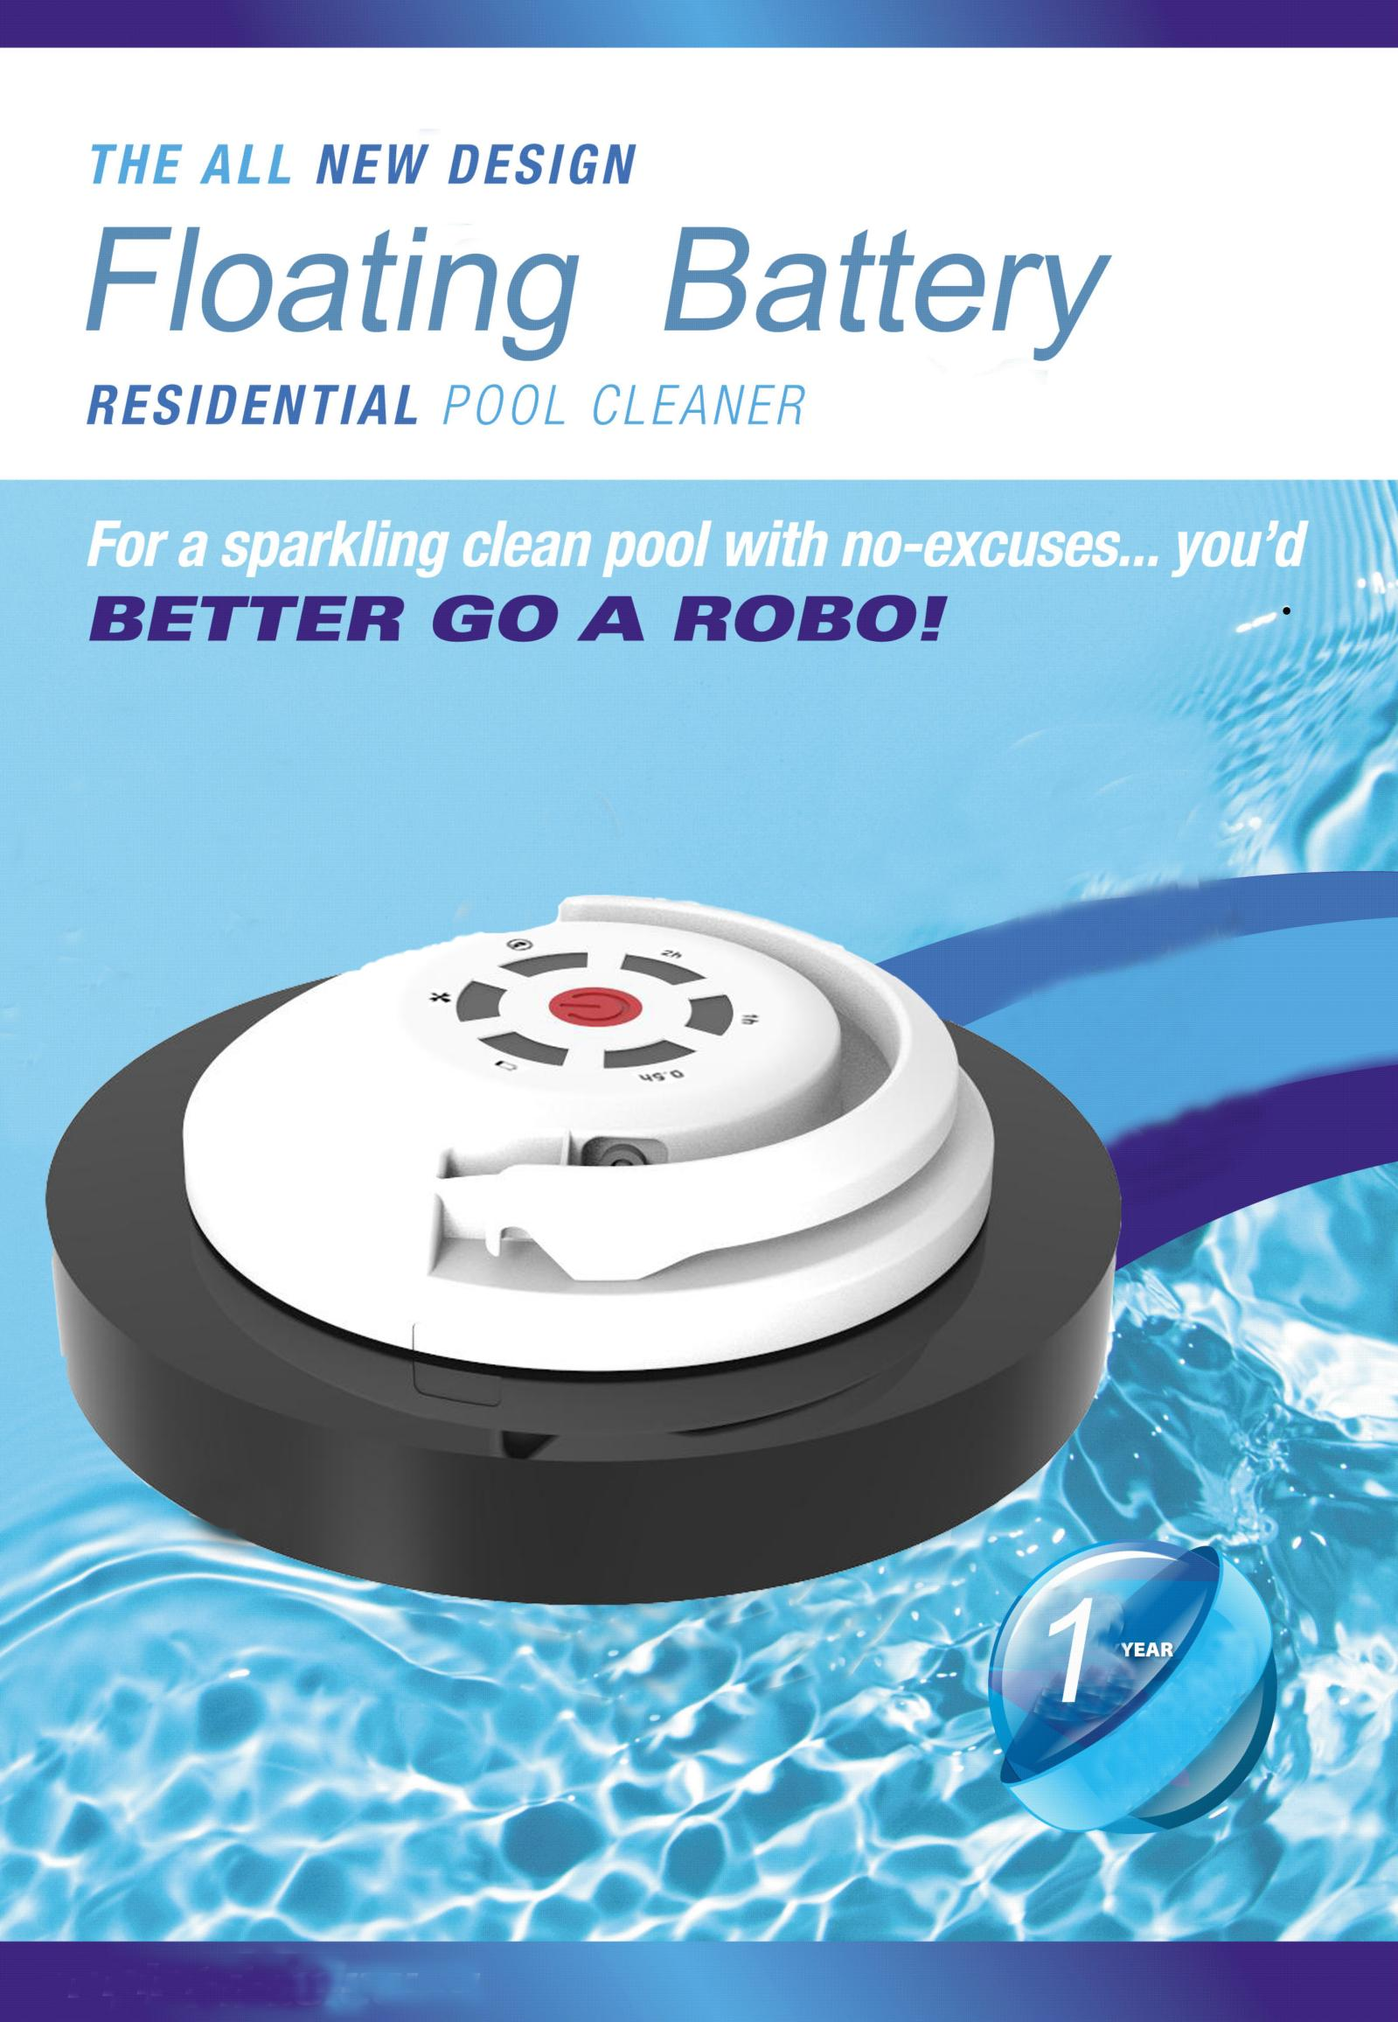
Use The Floating Battery

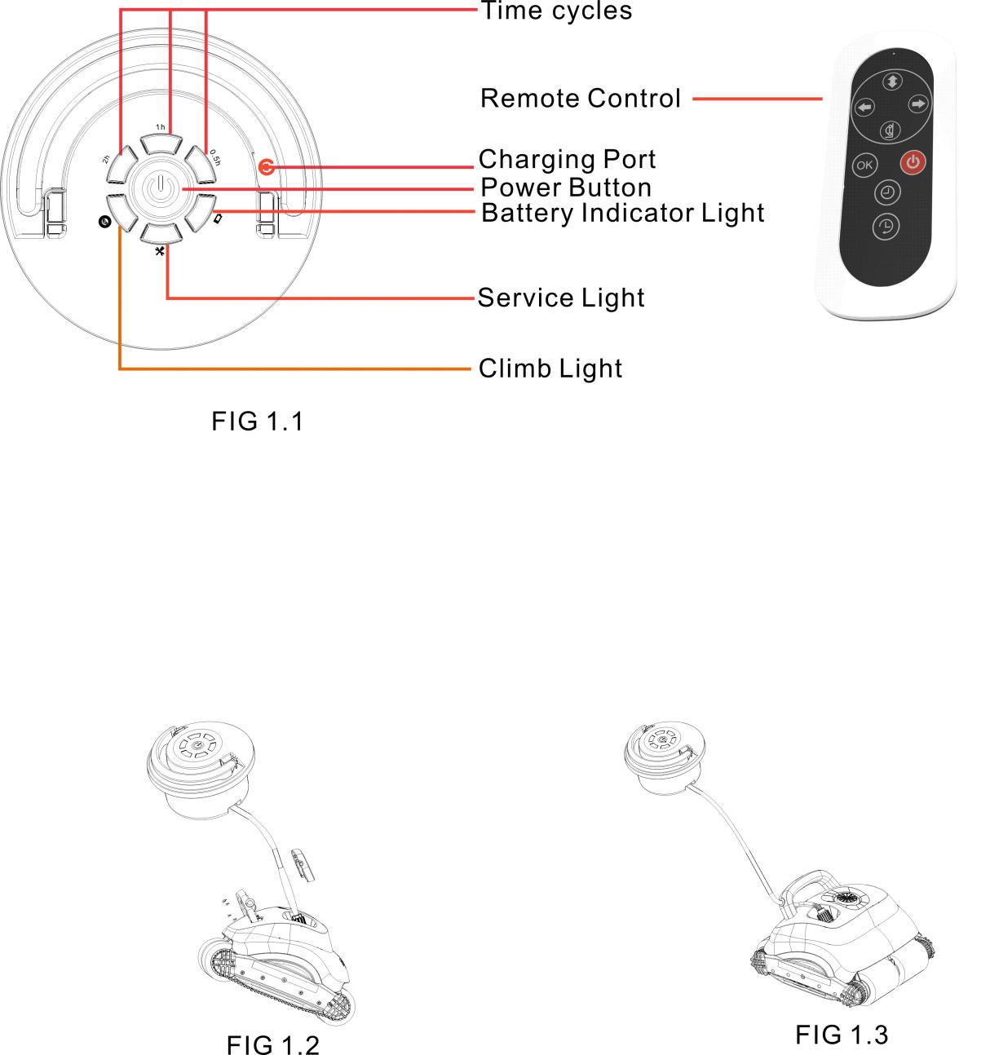

How to Connect the Floating Battery
.
1. Plug the black terminal on the end of Floating cable into the Robot.
2. Screw the black Nut on the floating cable to the Robot.
3. Put the Pool Cleaner into the water.
4. Press the power button on the Floating Battery and put it into the water.
5. Select the working time cycle and climb/no climb function by the Remote Control.

Note: The robot working time is 2 hours when the battery power is full.

Recharge
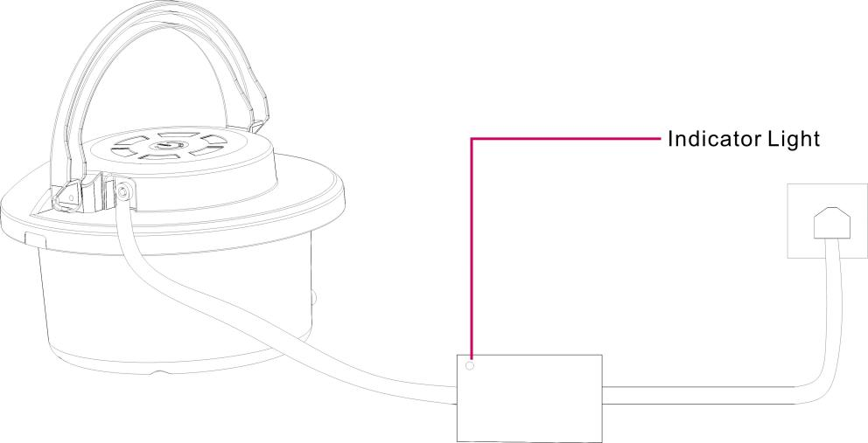

Please use the Charger to connect the Floating Battery and the 110/220v socket for about 8 hours
until the Indicator Light on the Charger becomes green.
Note: When we charge the Floating Battery we need to disconnect the Robot.

Floating Battery Repair

If your Floating Battery is within the scope of the warranty, we will replace it free of charge.
If your Floating Battery cannot be used due to accidental damage or improper use and storage,
we will charge a service fee. To learn more about Floating Battery and how to improve the
battery performance, please read the following.

Lithium ion Battery Facts

Batteries are a complex technology, and a number of variables contribute to battery
performance and the relevant Floating Battery performance.

1. Life: All rechargeable batteries have a limited lifespan, eventually they would need be
serviced and recycled. Based on your usage of Floating Battery, your battery life may vary.

2. When batteries chemically age: All rechargeable batteries are consumable components that
become less effective as they chemically age.

As lithium-ion batteries chemically age, the amount of charge they can hold diminishes,
resulting in shorter amounts of time before the Floating Battery needs to be recharged.

A battery’s impedance (the speed at which it looses charge) can increase if a battery has a higher chemical age. A battery’s impedance will temporally increase at a low state of charge and in a cold temperature
environment. When coupled with a higher chemical age, the impedance increase will be more
significant. These are characteristics of battery chemistry that are common to all lithium-ion
batteries in the industry. When power is pulled from a battery with a higher level of impedance,
the battery’s voltage will drop to a greater degree. Electronic components require a minimum
voltage to properly operate. This includes the Floating Battery’s internal storage, power circuits,
and the battery itself.

Battery’s Maximum Capacity

Maximum battery capacity measures the battery capacity relative to when it was new. Batteries
will start at 100% when first activated and will have lower capacity as the battery chemically
ages which may result in fewer hours of usage between charges. As the battery health degrades
so can its ability to deliver peak performance.

How to Maximise Battery Performance

1.”Battery life” is the amount of time the Floating Battery runs before it needs to be recharged.
“Battery lifespan” is the amount of time a battery lasts until it needs to be replaced. One factor
affecting battery life and lifespan is the mix of things you do with your Floating Battery.
No matter how you use it, there are ways to help. A battery’s lifespan is related to its
”chemical age,” which is more than just the passage of time. It includes different factors, such as
the number of charge cycles and how it was cared for. Follow these tips to maximize battery
performance and help extend battery lifespan. For example, keep Floating Battery half-charged
when it’s stored for the long term. Also avoid storing or charging it under high temperature
environment, including long-time exposure under the sun.

2.Full charge-discharge once per every three months to extend the battery life. If untreated for
a long time, the battery will be damaged. If the battery is damaged because of long-time storage
and failing to charge and discharge at a given time, we will charge a service fee during the
maintenance procedure.

3. The battery’s life is about 300 Charging Cycles if used in accordance with these instructions.

4. If the battery Indicator light is flashing, the Battery has low power and needs to be recharged.

5. If storing the battery for a long time, please charge to 75%.(All three time lights on, and Charger
still showing a RED L.E.D. Green LED is 100% charge, which is too much charge for
long term storage)

Remark: Please make contact with your local distributor for maintenance service.

